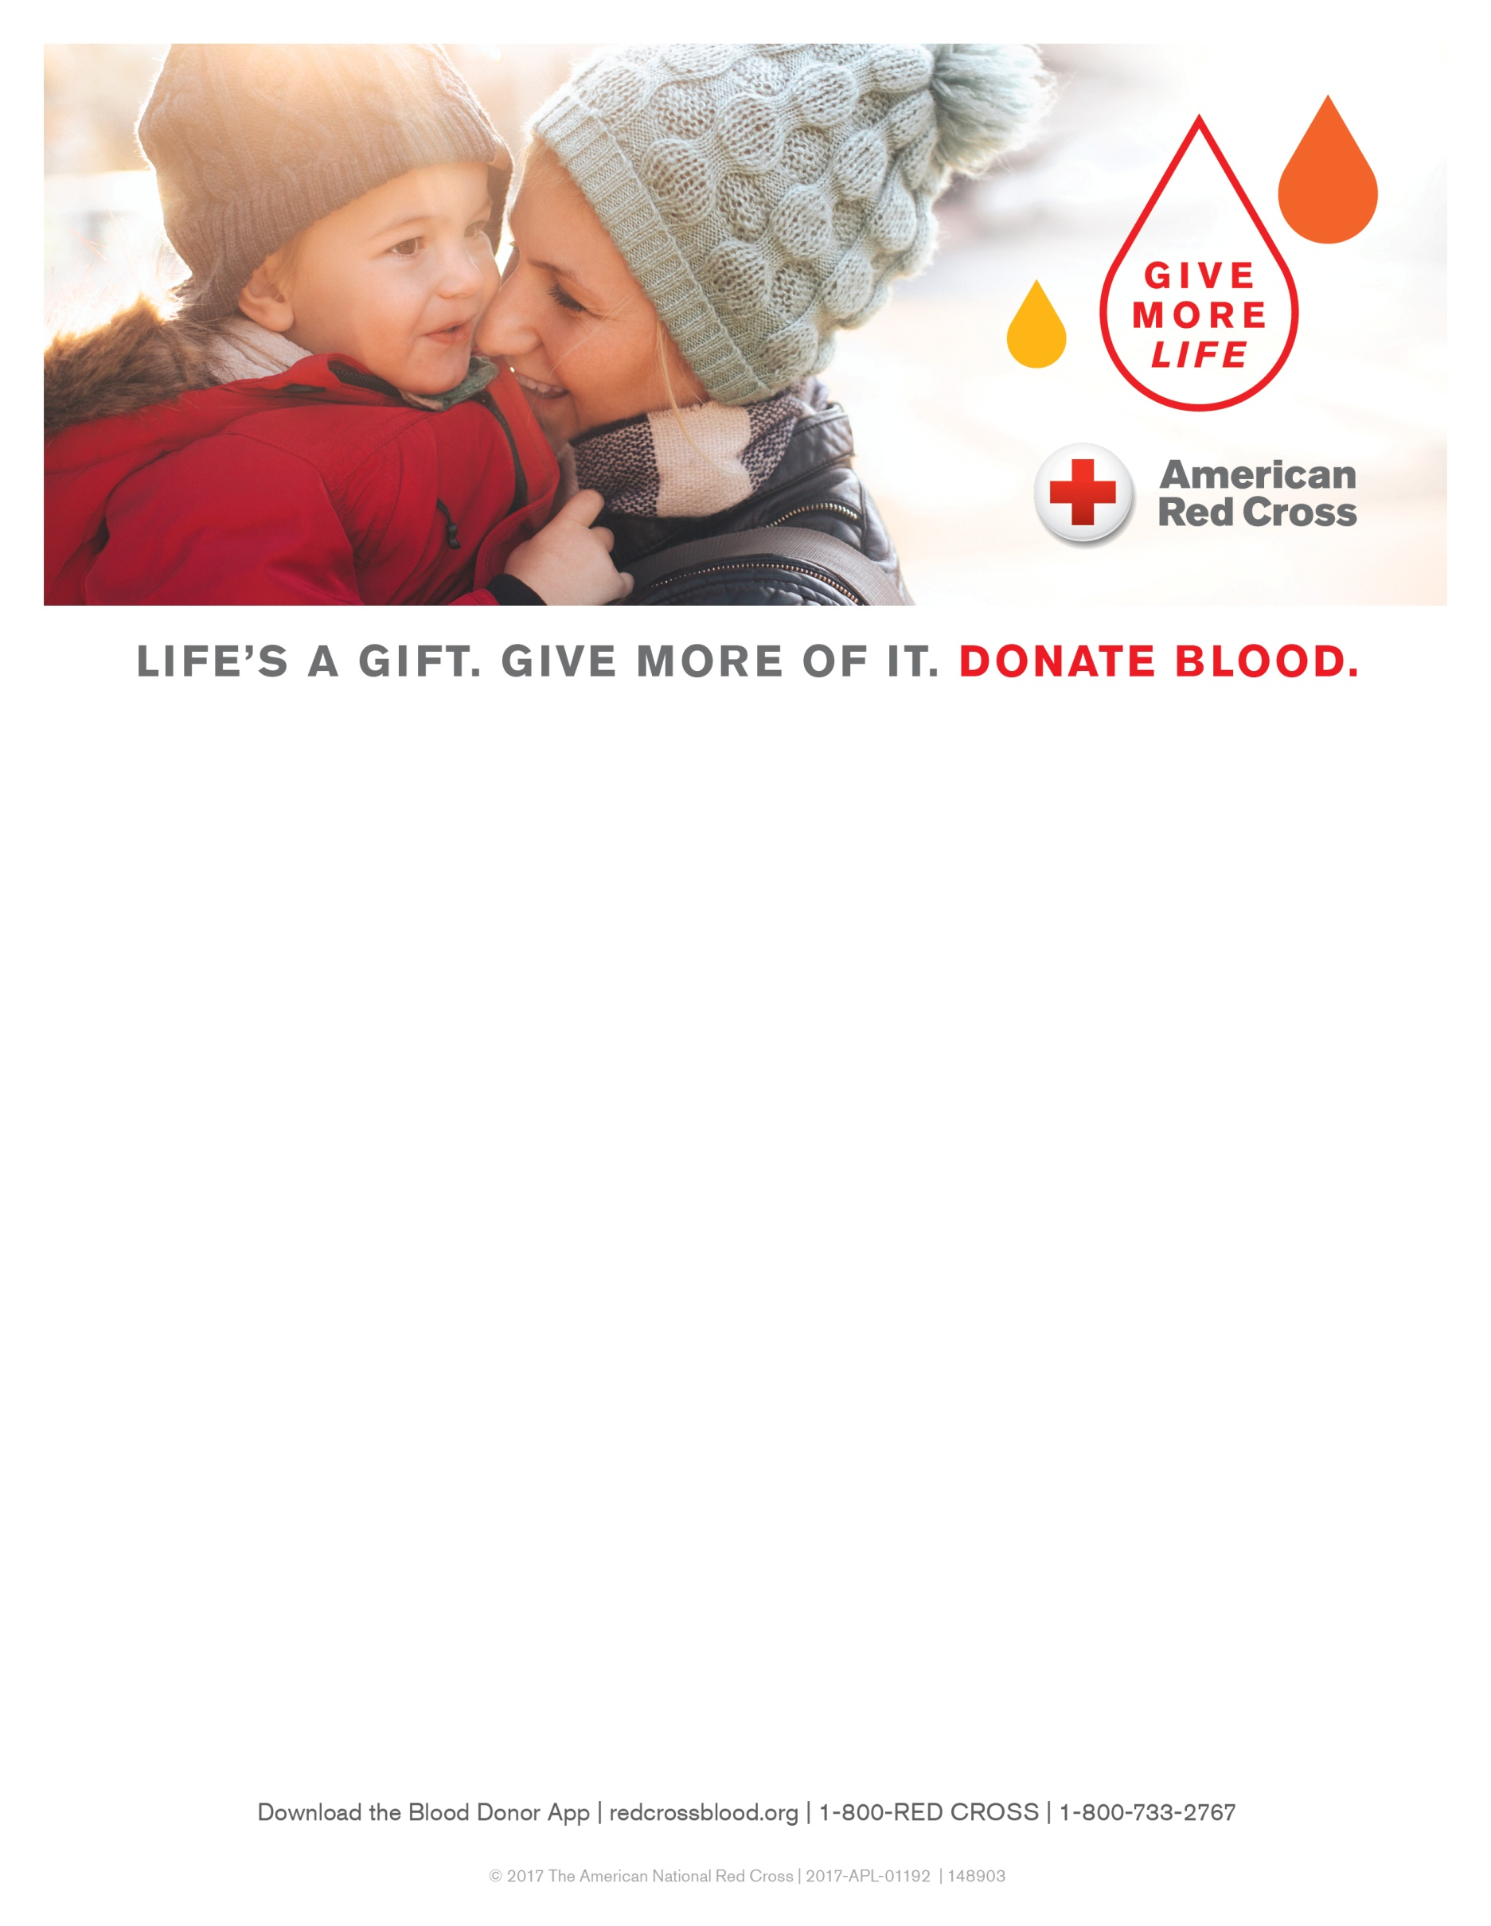

**32nd Annual Madison Holiday Blood Drive**

Friday, Dec. 22  
7 a.m.-2 p.m.

Exhibition Hall at the Alliant Energy Center   
1919 Alliant Energy Center Way  
Madison, WI 53713

**All presenting donors will receive a:**

* Free long-sleeved Red Cross T-shirt
* Chance to win great prizes*

*\*Prizes are not transferable and not redeemable for cash.*

Free parking, childcare, local entertainment and special refreshments will be provided.

Make your appointment today at **redcrossblood.org,   
sponsor code: HBDMadison**, or call **1-800-RED CROSS**.

*The American Red Cross will be hosting a food & fund drive for Second Harvest Foodbank*

*in conjunction with the Holiday Blood Drive.  Please bring non-perishable food items or*

*cash donations to the drive to help those facing hunger.*